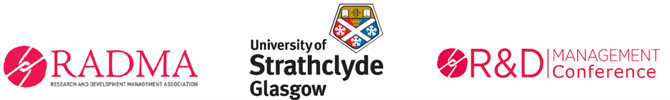

R&D Management Conference 2021
6th-8th July Online
Innovation in an Era of Disruption

Deadline: 17th March
For the first time our R&D Management Conference will take the form of a virtual, online event. We invite the submission of Extended Abstracts and Posters presenting academic research of a theoretical or empirical nature relating to the conference theme. Full details of submission requirements can be found in this Call for Papers.
The global Covid-19 crisis has made many companies realise that they cannot operate as they have in the past. This means that Innovation and R&D initiatives emerge as essential catalysts for post-pandemic growth. In this regard areas of particular relevance to the conference theme are, but not limited to, changing customer needs, new product and service offerings, business model disruption, digital transformation and emerging markets.
Crises create opportunities for both economic, social and environmental innovation manifest in the growing sharing economy and areas related to sustainability, clean technologies, energy and methods of production.
Consideration may also be given to organisational factors such as culture, leadership, capabilities, processes, structures and theories that underpin innovation implementation. The conference encourages forward thinking by assessing state-of-the-art trends and offers opportunities for discussions on a broad range of innovation related topics.
Keynote speakers, workshops and additional activities: In addition to the papers and poster tracks there will be a plenary session, showcasing University of Strathclyde’s response to Covid19. Keynote speakers include Professor Ellen Enkel, Mr Steve Rader, NASA and Industry contributors. Workshops, networking and other social activities will run for the duration of the conference and more details will follow.

Submission Details

Workshops, Tutorials, Masterclasses and Seminars
Submission deadline 17th March
Proposals for academic and industrially-oriented workshops, tutorials, seminars and other interesting and interactive sessions relevant to the domain of R&D Management are invited.
Examples: industry oriented-workshops, academic research workshops, research and teaching methodology tutorials and seminars, network building discussions, and ‘meet the editor’ sessions.
These sessions will be scheduled in a parallel track which will run for the duration of the conference. These sessions will consist of 1 hour blocks.
Proposals for a workshop, tutorial, masterclass or seminars should succinctly convey information about:
- The objectives of the session (max 100 words)
- How will it work (max 100 words )
- Who is expected to contribute (max 100 words )
- Whether the session is primarily: academic; practice focused or a mixture
- Proposals can be submitted via the online portal.

Review criteria: the proposals will be peer reviewed and the reviewer will be encouraged to score the submission according to these criteria:
- Is the workshop/tutorial/seminar interesting for the R&D Management community?
- Is its purpose or value clearly evident?
- Is the plan feasible?
- Who is it likely to benefit/participate? (Is it likely to attract an audience)?

